Quiz #8

I own a restaurant and the curve on the left depicts how many meals I can produce in an hour (MP of labor curve if I hire differing numbers of workers. (*Meals/hr* on the vertical axis and *people* on the horizontal) My crappy meals sell for $4. 1) Use that information to develop the VMP of labor curve and to label the axes (and units) appropriately.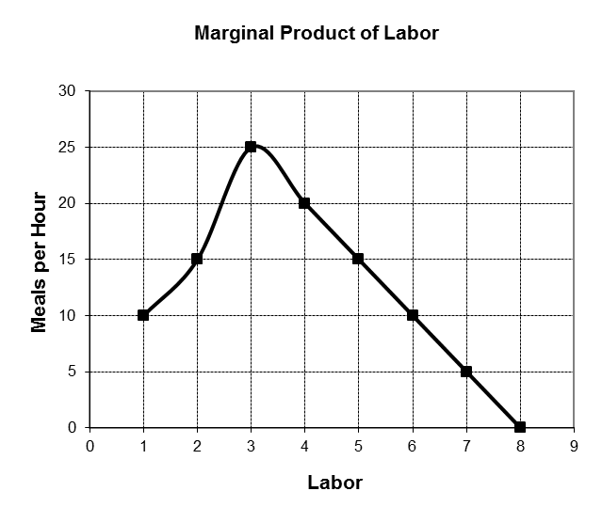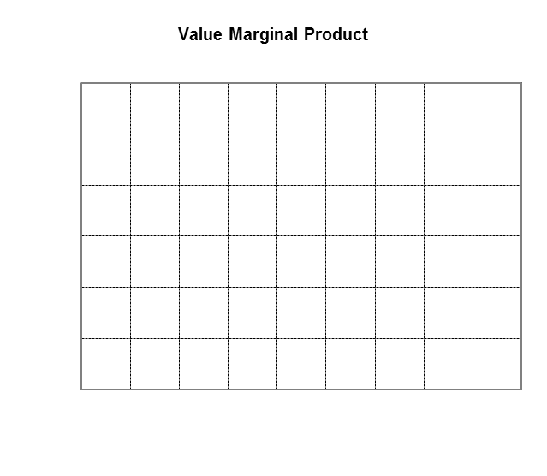

2) If I’m a profit-maximizing employer and I can hire all the workers I want at $19/hr., how many workers should I hire? Explain why.

**Hire 3 workers because hiring more will no longer maximize your profits. In order to maximize profits, you should continue to increase labor until the value of labor’s marginal product is equal to the wage.**

3) Use this simple example to develop and explain Clark’s argument about the factors that determine why people earn as much or as little as they do (e.g., marginal physical product, price of the product, value of the marginal product, the demand and supply of labor).

**According to Clark, firms are only willing to pay a laborer for the utility and productivity that they contribute to the firm. Buying more labor will maximize profits because it adds less utility to the firm.**

4) Identify every component of Clark’s analysis of income distribution that is linked to utility calculations of individuals in the economy.

**It is key for the marginal product to equal the wage if a firm wants to maximize profits. The value of marginal product of labor is equal to the money or the product’s selling price per unit.**

5) Clark argued that unobstructed capitalism “assigns to everyone what he (sic) has specifically created.” Given this argument, what effects would Clark predict from raising the minimum wage? Explain.

**Clark argues that if workers are paid the value what they are producing, there is no exploitation and no surplus for anyone to claim. The wages are adjusted between the worker and the firm; their wage equals the labor they produced. As the minimum wage rises, people would lose the incentive to work harder therefore they would produce less and become lazy.**

6) Given Clark’s argument, what types of policies might be appropriate for narrowing inequality in the distribution of income if one were inclined to intervene in markets? Explain.

**A policy that would be appropriate for narrowing the inequality in the distribution of income would be laisse-faire.**

On graph